**Assignment 5**

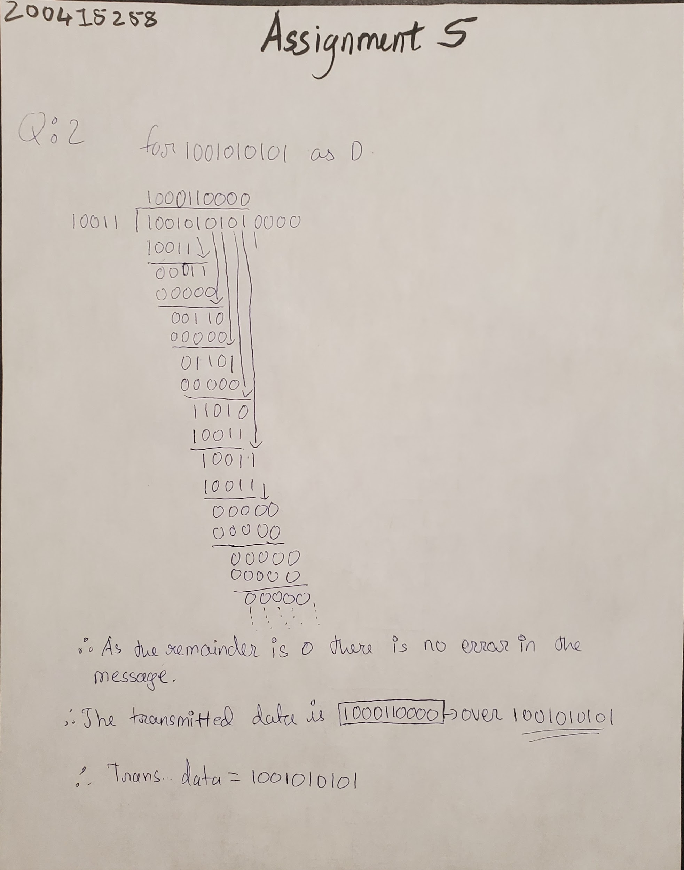

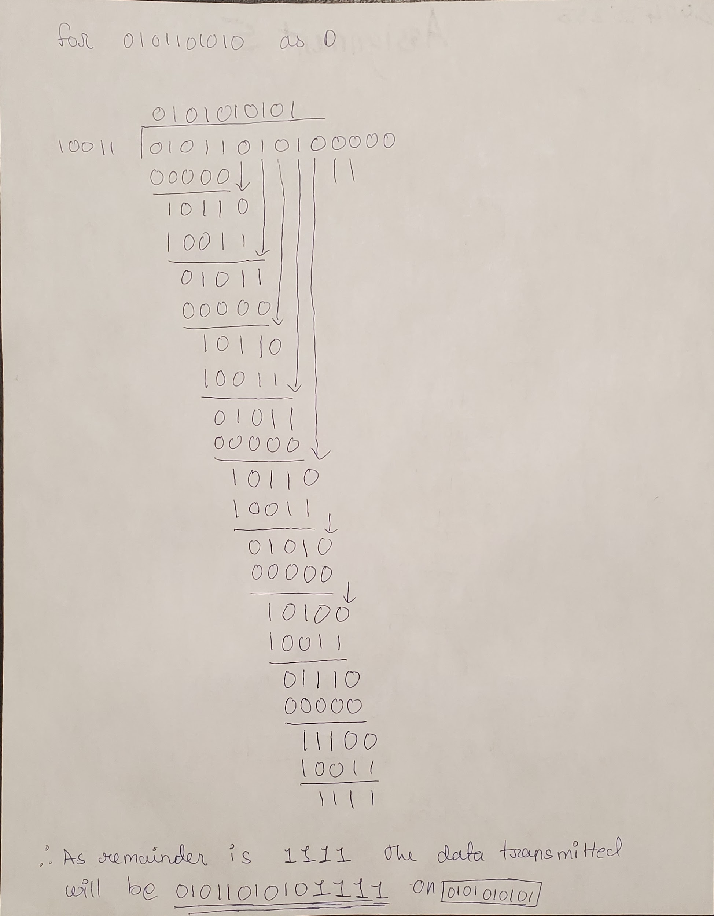

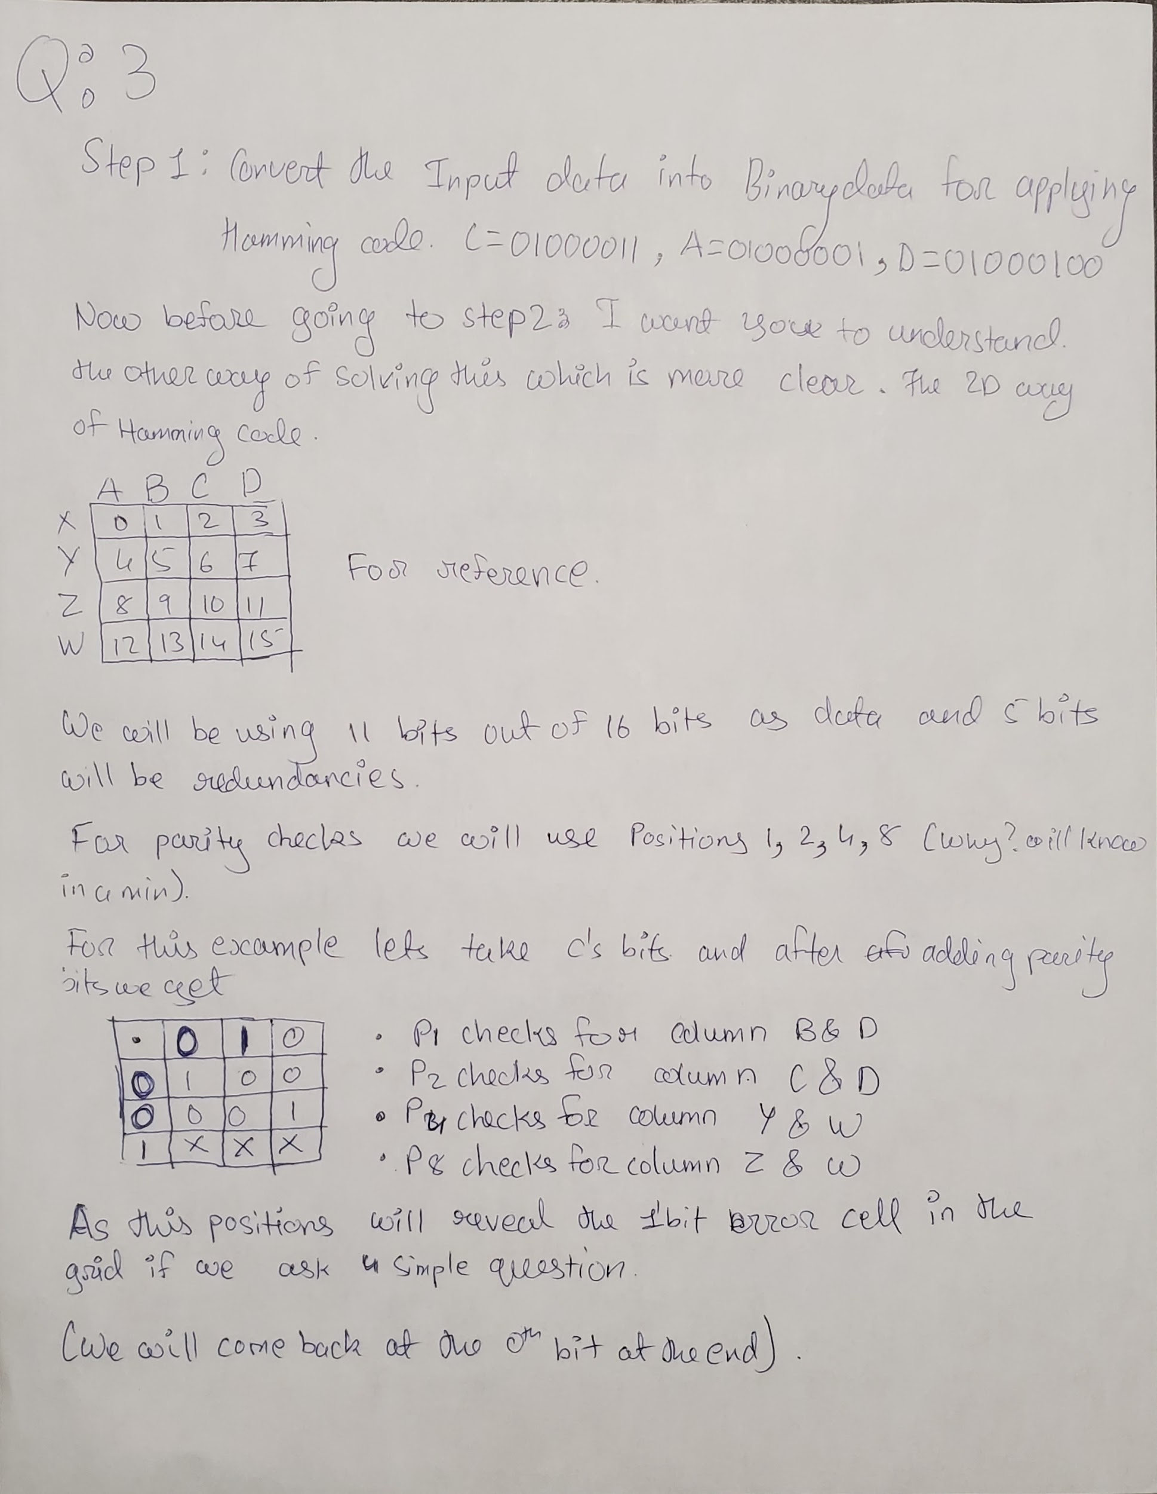

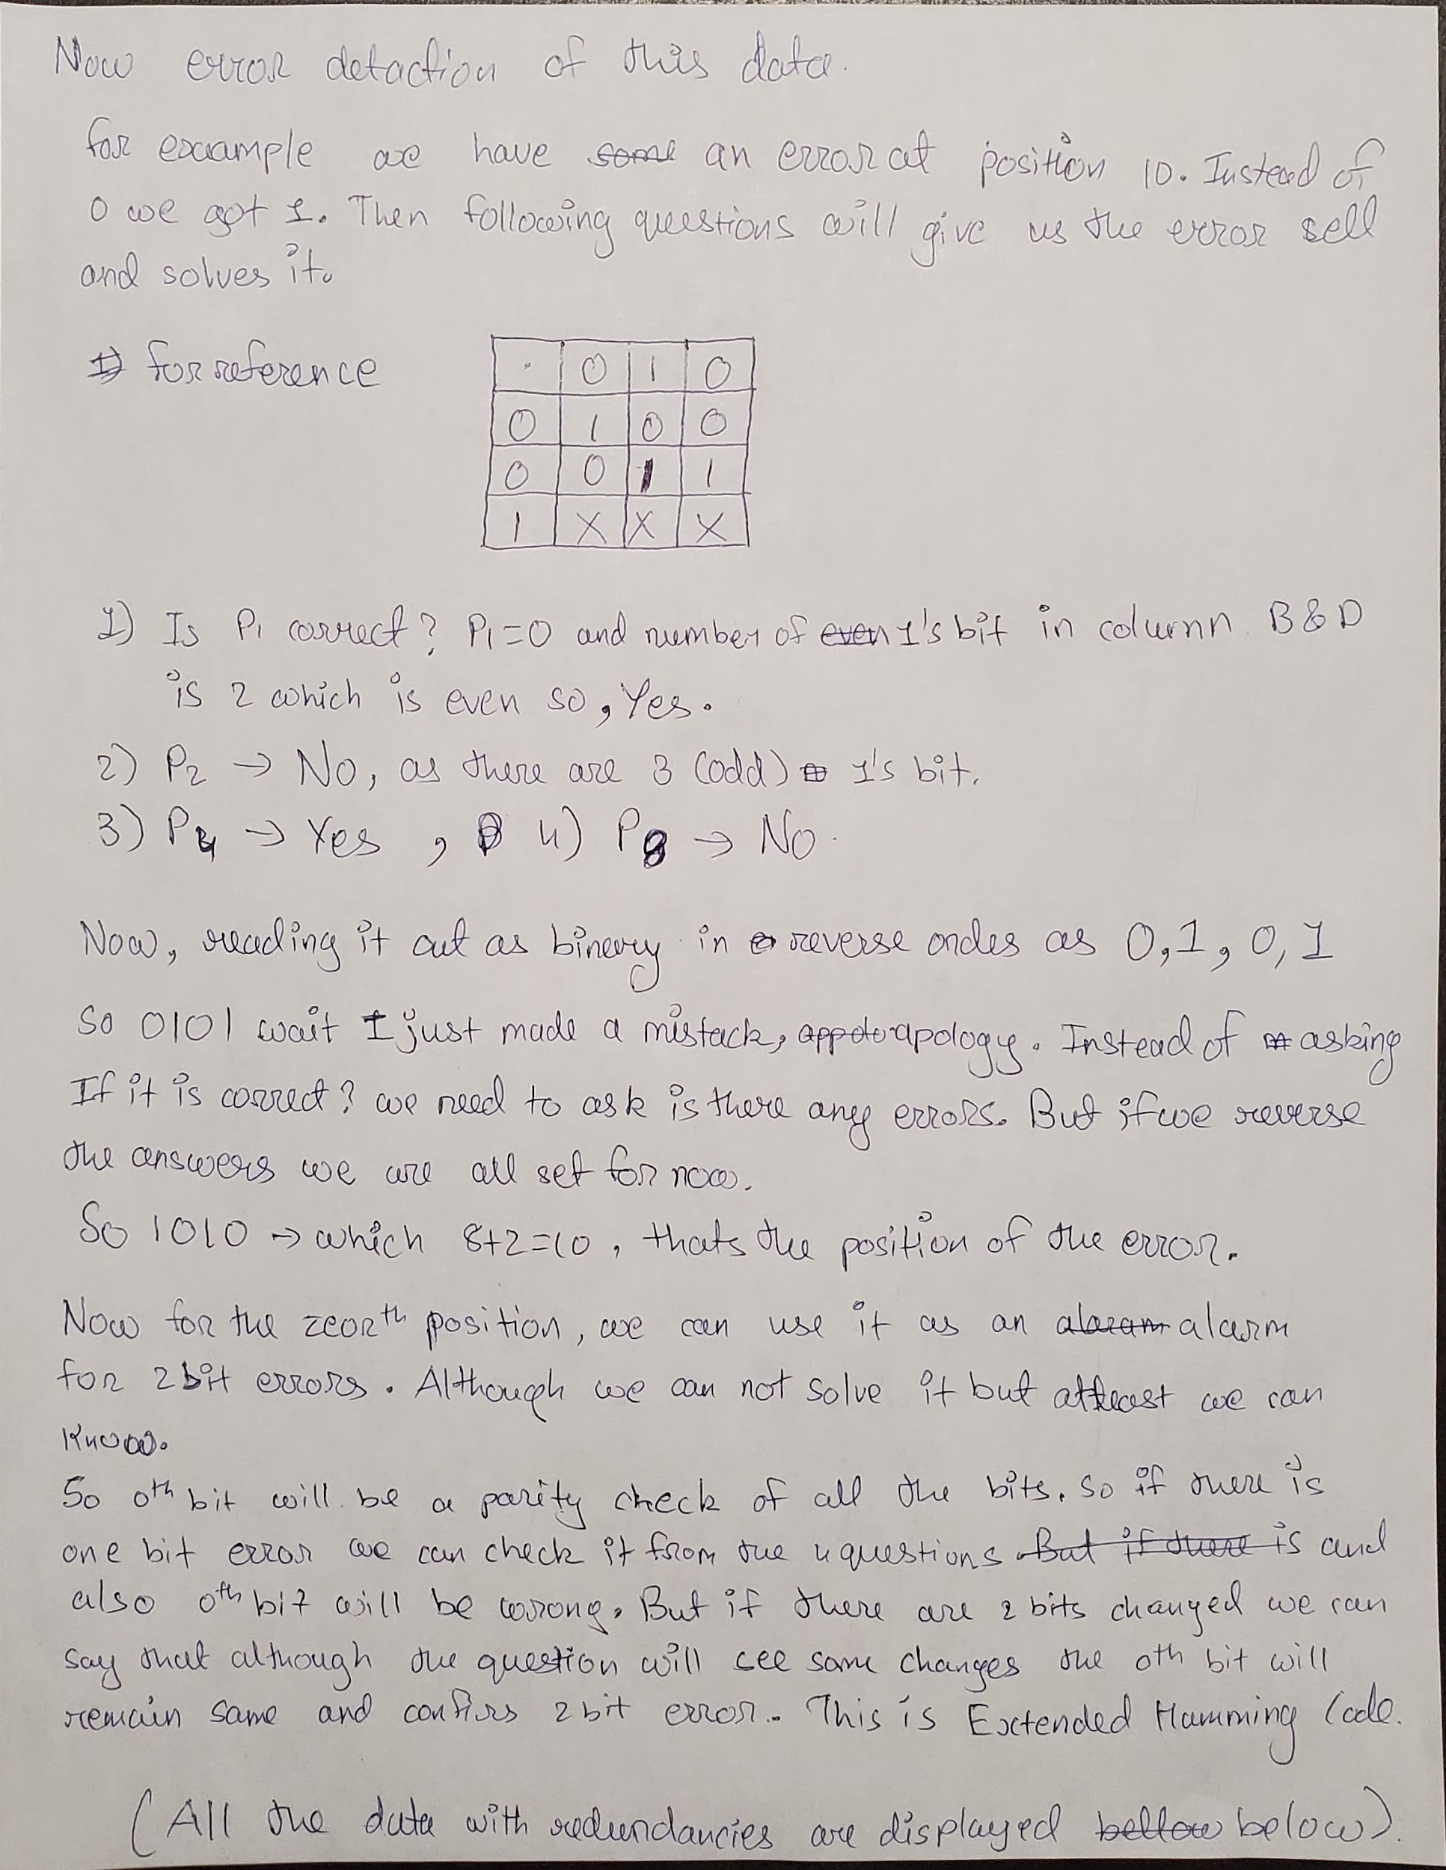

Ans: For C the data with the redundancies is

| 0 | 0 | 1 | 0 |
| --- | --- | --- | --- |
| 0 | 1 | 0 | 0 |
| 0 | 0 | 0 | 1 |
| 1 | X | X | X |

For A = 01000001 the data with the redundancies is

| 0 | 1 | 0 | 0 |
| --- | --- | --- | --- |
| 0 | 1 | 0 | 0 |
| 1 | 0 | 0 | 0 |
| 1 | X | X | X |

So if the 5th bit of A which is 0 had an error and got converted to 1 so now the data will be;

| 0 | 1 | 0 | 0 |
| --- | --- | --- | --- |
| 0 | 1 | 0 | 0 |
| 1 | 1 | 0 | 0 |
| 1 | X | X | X |

Now answering 4 question

1. Is there any error in B and D - YES
2. Is there any error in C and D - NO
3. Is there any error in Y and W - NO
4. Is there any error in Z and W - YES

So the binary will be 1001 which is 9 and at the ninth position we change the bit to 0 again.

For D = 01000100 the data with the redundancies is

| 0 | 1 | 1 | 0 |
| --- | --- | --- | --- |
| 1 | 1 | 0 | 0 |
| 1 | 0 | 1 | 0 |
| 0 | X | X | X |

**4. (10 points) Consider three LANs interconnected by two routers as shown below.**

1. **Assign IP addresses to all of the interfaces. For Subnet 1 use addresses of the form 192.168.1.xxx; for Subnet 2 use addresses of the form 192.168.2.xxx; and for Subnet 3 use addresses of the form 192.168.3.xxx.**

Ans: For Subnet 1,

Router will get the first ip address as: 192.168.1.001

Then comes Host A with ip address: 192.168.1.002

Host B with ip address: 192.168.1.003

For Subnet 2,

Router 1’s ip address as: 192.168.2.001

Router 2’s ip address as: 192.168.2.002

Host C with ip address: 192.168.2.003

Host D with ip address: 192.168.2.004

For Subnet 3,

Router’s ip address as: 192.168.3.001

Host E with ip address: 192.168.3.002

Host F with ip address: 192.168.3.003

1. **Assign MAC addresses to all of the adapters.**

Ans: MAC addresses on each subnet we have,

For Subnet 1,

Router will get the first mac address as: 00:00:00:00:00:00

Host A with mac address: 11:11:11:11:11:11

Host B with mac address: 22:22:22:22:22:22

For Subnet 2,

Router 1’s mac address as: 33:33:33:33:33:33

Router 1’s mac address as: 44:44:44:44:44:44

Host C with mac address: 55:55:55:55:55:55

Host D with mac address: 66:66:66:66:66:66

For Subnet 3,

Routers mac address as: 77:77:77:77:77:77

Host E with mac address: 88:88:88:88:88:88

Host F with mac address: 99:99:99:99:99:99

1. **Consider sending an IP datagram from Host E to Host B. Suppose all of the ARP tables are up to date. Enumerate all steps, as done for the single router example in Section 5.4.1.**

Ans: Considering that the ARP tables are all up to date, if we want to send the datagram from Host E to Host B following steps will be taken in the network;

1. From the forwarding table Host E knows that passing datagram to Host B requires it to send its data to the Subnet 3’s router at the IP address 192.168.3.001.
2. From the IP address Host E will get the MAC address of the router as 77:77:77:77:77:77
3. Router 2 (which connects subnet 2 and 3) will receive the datagram and knows that inorder to send datagram to Host B it needs to send it to Router 1 (which connects Subnet 1 and 2).
4. Router 2 has the IP address of Router 1 as 192.168.2.002
5. From the forwarding table, Router 2 sends datagram to MAC address 33:33:33:33:33:33 (Router 1)
6. Again doing the same steps from Router in the Subnet 1 to Host B.
7. **Repeat (c), now assuming that the ARP table in the sending host is empty (and all other tables are up to date).**

Ans: If Host E does not have an ARP table up to date but everyone else has, than the following steps will be performed for Host E to send datagram to Host B;

1. Host E will ask for the mac address of the router via its ip address 192.168.3.001 from forwarding table.
2. Router will respond to Host E with its MAC address 77:77:77:77:77:77
3. Now Host E will send the datagram to Router and then the steps will be continued as Router will have ARP of its own up to date.